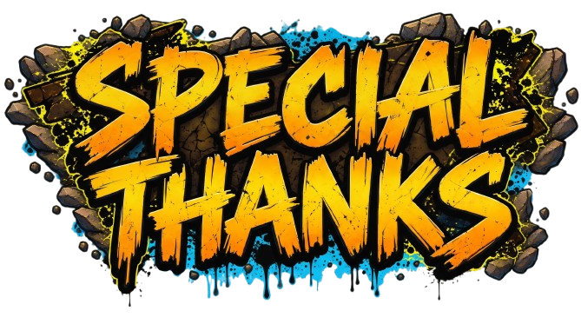
Mattmab
RDP/Squiggs
Cr4nkSt4r
Azalea Asvail
TobGun1

FUNKYOURSHiFT

Skippy

Nicnl & InflamedSebi

Ynot

NOTE: If I left anyone out, please let me know!

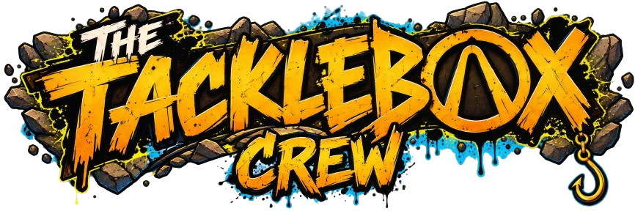

Captain Fail

Cceil6

CG1138

K1ngFern

Easy_E_Monceaux

Wakimm

NorfolkAJ

Kryp

Bubbles

